**DAY 11 LIT ASSIGNMENT**

**Name : Abdul Sameerunnisa**

**ID : 46247725**

**Smartform Name : ZAS_LIT_SMARTFORM**

**Style : Z7725_STYLE**

**Report Name : ZAS_LIT_SMARTFORM**

**Table : ZAS_EMPLOYEE**

**Employee Data :**

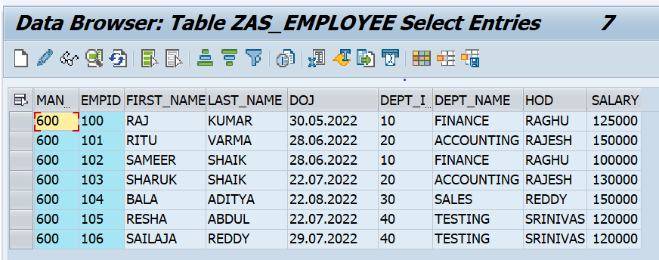

**Smartform :**

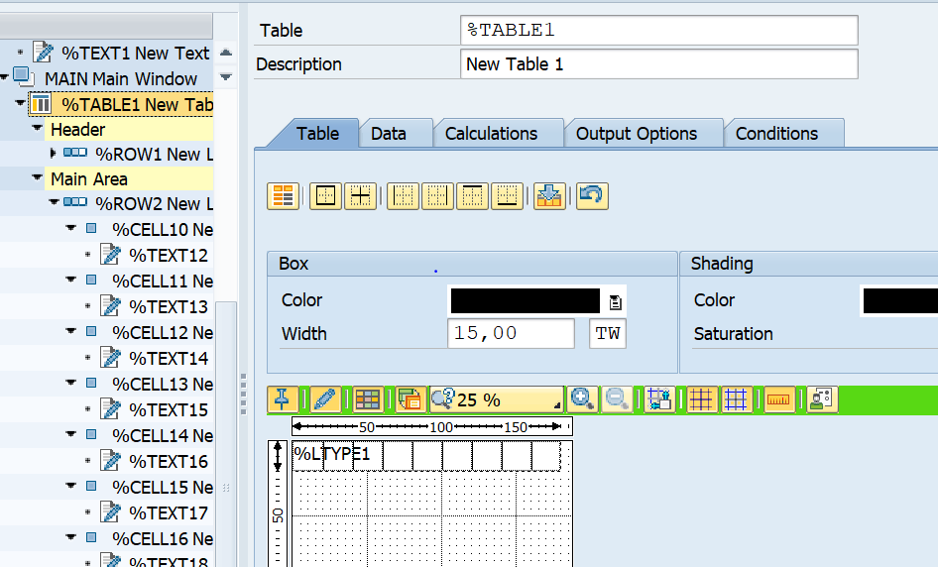

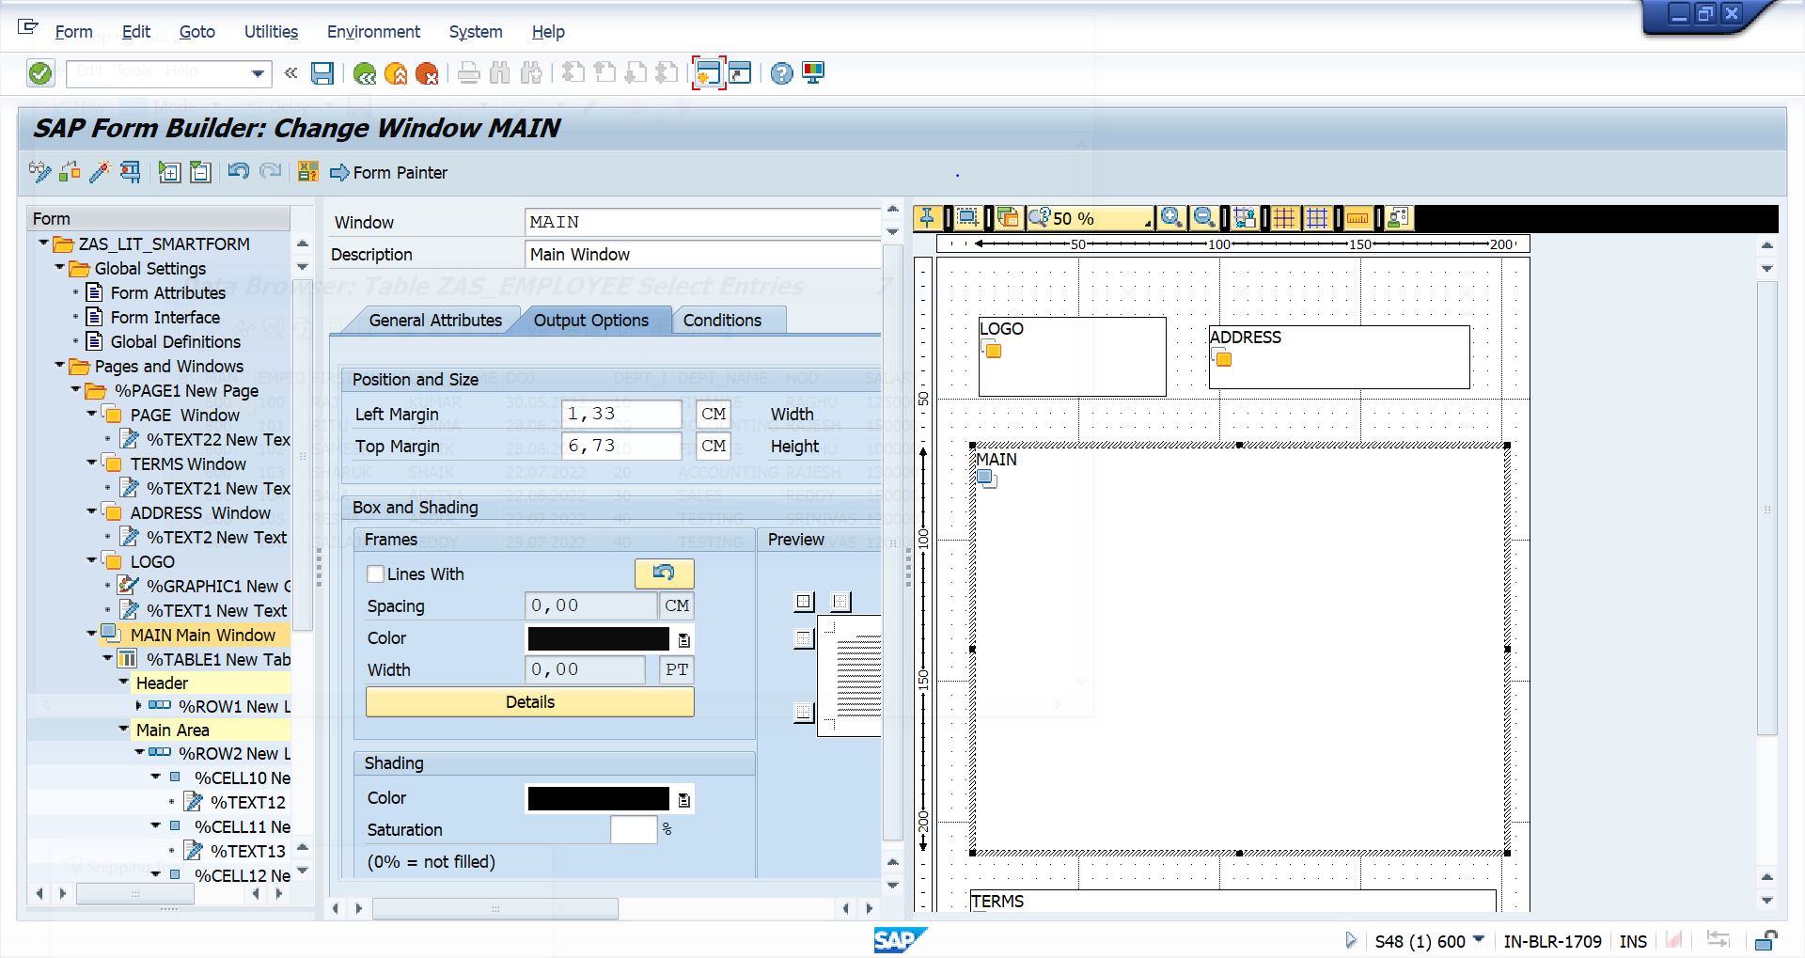

**Report :**

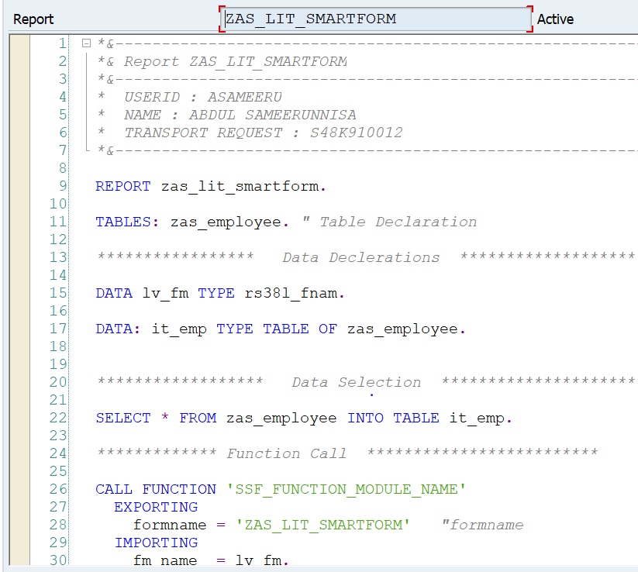

**Style :**

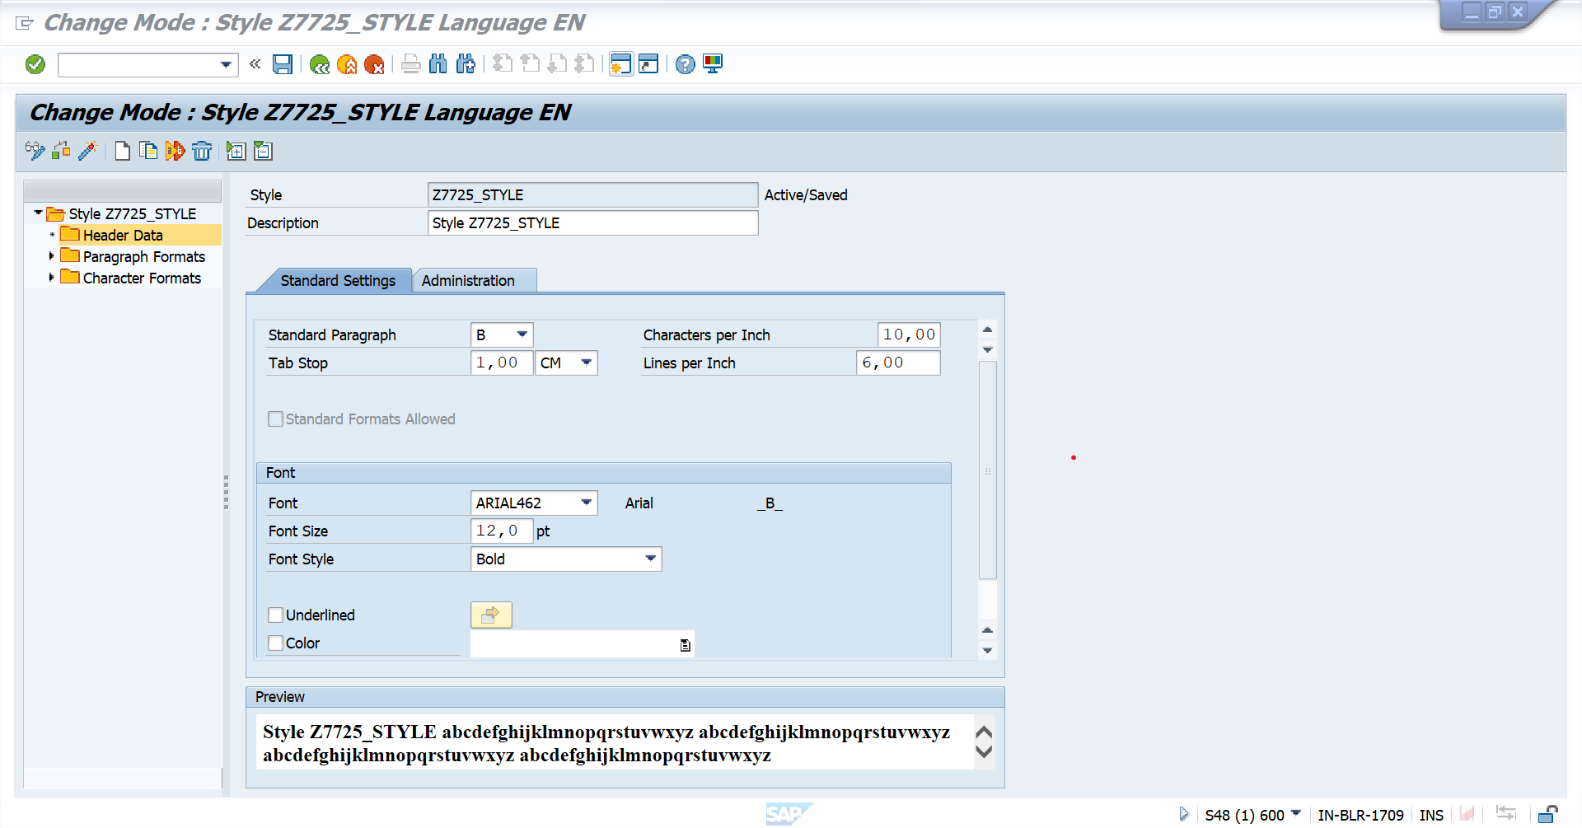

**OUTPUT :**

